**1.Introduction:-**

* ResultSet is an interface of java.sql package. It is a table of data representing a database query result.
* The Records in ResultSet object maintains 1based index.
* The columns in ResultSet object maintains 1 based index.
* By Default, Every Result object have 2 default positions:
* a)BFR(Before First Record)
* b)ALR(After Last Record)
* The ResultSet Object maintains a cursor that pointing to rows of query result. Initially cursor points to before the first row(BFR).­­­­­

The Implementation class name of ResultSet Interface is changed from driver s/w to driver s/w. Remembering Implementation class name and Declaring implementation class type variable is difficult to programmer. Therefore it is better to refer the implementation class object by the ResultSet type variable.

The ResultSet implementation class object is returned by following methods.

createStatement();

createPreparedStatement();

createCallableStatement();

These methods present in Connection interface.

Example:-

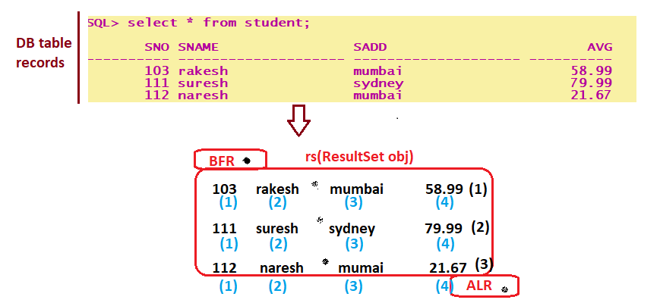

**2.ResultSet Types:-**

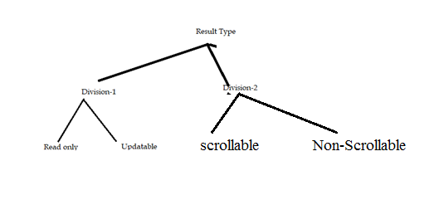

Division1:- Based on operations performed on ResultSet, we can divide ResultSet into 2 types.

1. Read Only ResultSets(Static ResultSets) :- we can perform only read operations on the ResultSet by using corresponding getter methods and we can not perform any updations.

By default ResultSet is Read Only.

We can specify explicitly ResultSet as Read only by using the following constant of ResultSet.

Public static final int CONCUR_READ_ONLY 🡪1007.

1. Updatable ResultSets(Dynamic ResultSets):- The ResultSet which allows programmer to perform updations, such type of ResultSets are called updatable ResultSets. These updations can be made permanent to DB.

In this case we can perform select,insert,delete and update operations.

We can specify ResultSet explicityly as updatable by using the following constant of ResultSet.

Public static final int CONCUR_UPDATABLE🡪1008.

* Updatable resultset allows the programmer to perform insert,update and delete database operations with out using SQL queries.
* Very few drivers supports for updatable resultsets.

Ex:- Type1 driver supports .

Type2 supports but we should not use * in SQL query and we should use column names.

**Division2:-**

1. **Non-Scrollable Result(Sequential Result Set/ UniDirectional Result set)Set:-** This result set object allows us to access the records only in one direction that is top to bottom.

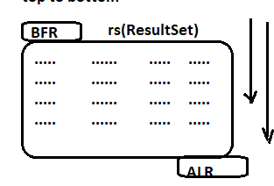

Limitation:- To access the 100 th record of result set object, we need to go through 99 records. So It is time consuming process.

By default, every result object is sequential result object.

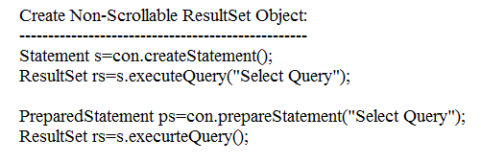

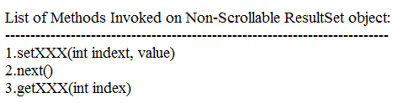

**2. Non-Scrollable Result Set(Bi-Directional ResultSet/Non-Sequential ResultSet):-** we can access records top to bottom, bottom to top, randomly and directly.

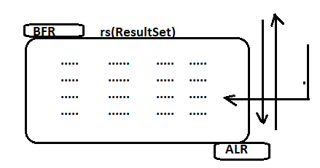

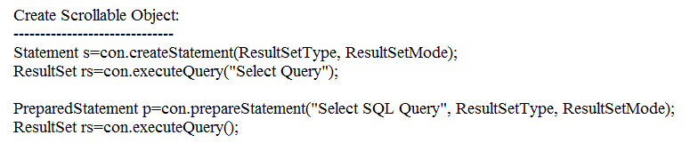

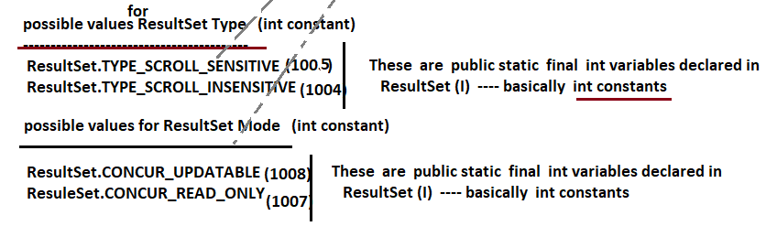

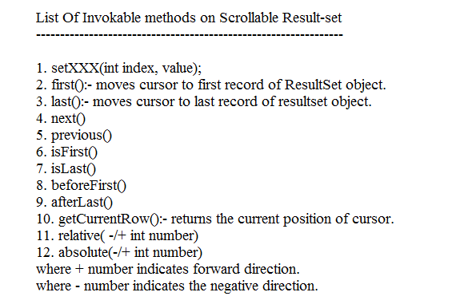

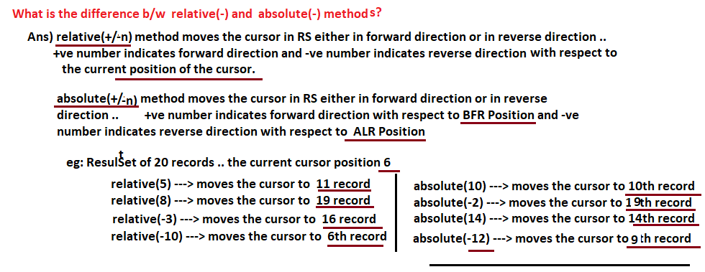

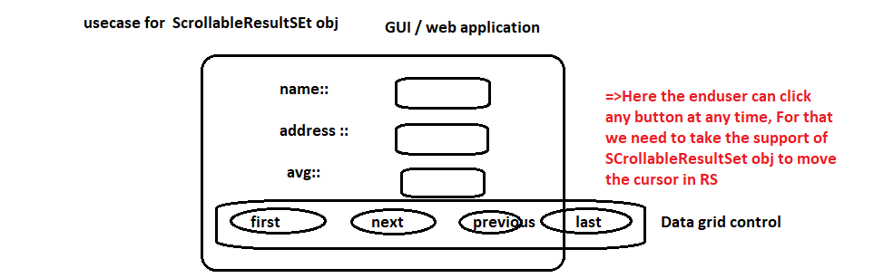

The scrollable resultset can be

1. Sensitive ResultSet.
2. InSensitive ResultSet.
3. ReadOnly ResultSet.
4. Updatable Resultset.

**2.1.Sensitive ResultSet:-** If changes done in db table records immediately are reflects to Resultset object is called Sensitive ResultSet.



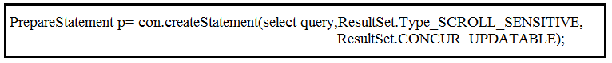

Note:-

1. Do not use “*” in select query.
2. Call refreshRow() method in while loop which process the resultSet.
3. All JDBC driver softwares does not support Sensitive ResultSet.

Oracle Type4 driver supports.

UseCases:- Live game score display, Stock market share value display.

**2.2.InSensitive ResultSet:-**  If changes done in db table records are not reflects to Resultset object is called Insensitive resultset.

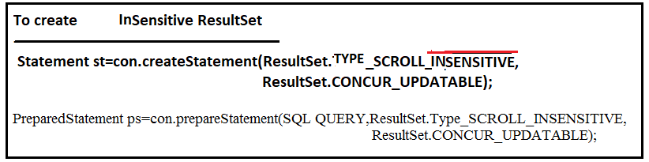

UseCases:- Sales Report, Bank statement report.

**2.3. ReadOnly ResultSet:-** we can perform only read operations on the ResultSet by using corresponding getter methods and we can not perform any updations.

By default ResultSet is Read Only.

We can specify explicitly ResultSet as Read only by using the following constant of ResultSet.

Public static final int CONCUR_READ_ONLY 🡪1007.

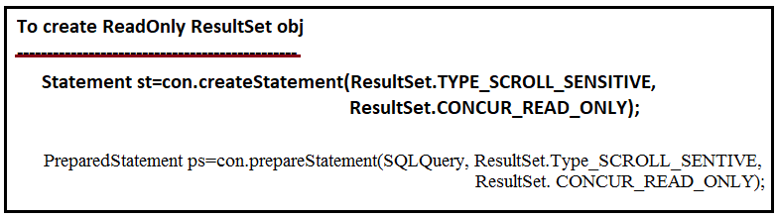

**2.4. Updatable ResultSet:-** The ResultSet which allows programmer to perform updations, such type of ResultSets are called updatable ResultSets. These updations can be made permanent to DB.

In this case we can perform select,insert,delete and update operations.

We can specify ResultSet explicityly as updatable by using the following constant of ResultSet.

Public static final int CONCUR_UPDATABLE🡪1008.

* Updatable resultset allows the programmer to perform insert,update and delete database operations with out using SQL queries.
* Very few drivers supports for updatable resultsets.

Ex:- Type1 driver supports .

Type2 supports but we should not use * in SQL query and we should use column names.

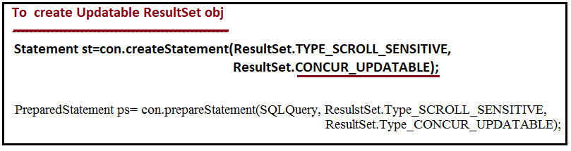

1. **moveToInserRow(): It creates** a new row in ResultSet object.
2. **insertRow(): It inserts new row in table.**
3. **updateXXX(colindex, value):-** It update a value in specified column of row which is pointed by cursor.
4. **deleteRow():-** It delete a row from db table.
5. **updateRow():-**It update row in db table.